HEART DISEASE ANALYSIS
Project Report

Team ID: LTVIP2026TMIDS24884

INTRODUCTION
  - Project Overview
  - Purpose

IDEATION PHASE
  - Problem Statement
  - Empathy Map Canvas
  - Brainstorming

REQUIREMENT ANALYSIS
  - Customer Journey map
  - Solution Requirement
  - Data Flow Diagram
  - Technology Stack

PROJECT DESIGN
  - Problem Solution Fit
  - Proposed Solution
  - Solution Architecture

PROJECT PLANNING & SCHEDULING
  - Project Planning

FUNCTIONAL AND PERFORMANCE TESTING
  - Performance Testing

RESULTS
  - Output Screenshots
- ADVANTAGES & DISADVANTAGES
- CONCLUSION
- FUTURE SCOPE
- APPENDIX
Source Code(if any) Dataset Link
GitHub & Project Demo Link

- INTRODUCTION

1.1 Project Overview
The Heart Disease Analysis project is designed to provide a comprehensive system for analyzing patient health data to predict the likelihood of heart disease. Using a combination of data analytics, visualization, and predictive modeling, the project enables healthcare professionals to quickly assess patient risk factors and make informed decisions. The system integrates patient demographic data, medical test results, and lifestyle parameters to generate a Risk Score and provide actionable insights through interactive dashboards.
1.2 Purpose
The primary purpose of this project is to improve early detection and preventive care for patients at risk of heart disease. By leveraging data analytics and predictive modeling, the project aims to:
- Enable healthcare professionals to identify high-risk patients quickly.
- Provide a visual representation of patient data for easier interpretation.
- Reduce the chances of late diagnosis by highlighting key risk indicators.
- Serve as a decision support tool for hospitals, clinics, and health monitoring agencies.

- IDEATION PHASE
2.1 Problem Statement
Heart disease is one of the leading causes of mortality worldwide. Early detection and intervention significantly improve patient outcomes. However, most hospitals face challenges such as manual data analysis, delayed diagnosis, and scattered patient records. The project addresses these challenges by providing a centralized analytical platform that processes patient data and predicts heart disease risk accurately.
2.2 Empathy Map Canvas
- Think & Feel: Patients may feel anxious about their health; doctors need reliable tools to make accurate decisions.
- Hear: Medical advice, lab results, and recommendations from peers.
- See: Multiple patient reports, lab charts, and medical histories.
- Say & Do: Patients report symptoms; doctors analyze data manually.
- Pain Points: Time-consuming analysis, high risk of errors, delayed detection.
- Gain Points: Quick risk assessment, clear visual insights, accurate predictions.
2.3 Brainstorming
- Use predictive modeling to assess heart disease risk.
- Implement interactive dashboards for visualization.
- Include filters for age, gender, blood pressure, cholesterol, etc.
- Provide a calculated Risk Score for each patient.
- Offer story/report generation for hospital administrators.

- REQUIREMENT ANALYSIS
3.1 Customer Journey Map
- Patient data is collected during routine check-ups.
- Data is uploaded to the Heart Disease Analysis system.
- The system preprocesses and cleans the data.
- Interactive dashboards allow doctors to filter and visualize patient data.
- Risk Score is calculated and displayed for each patient.
- Reports are generated for high-risk patients to aid in preventive measures.
3.2 Solution Requirement
- Functional Requirements: Data upload, preprocessing, Risk Score calculation, dashboard visualization, filtering, reporting.
- Non-Functional Requirements: Accuracy of predictions, fast response time (<3 seconds), user-friendly interface, secure data handling.
3.3 Data Flow Diagram
- Input: Patient demographic and medical data.
- Processing: Data cleaning, normalization, risk score calculation, visualization.
- Output: Dashboards, reports, and notifications for high-risk patients.
3.4 Technology Stack
- Frontend/Visualization: Tableau, Power BI
- Backend/Processing: Python (pandas, NumPy), Jupyter Notebook
- Database: MySQL / CSV datasets
- Libraries: scikit-learn for predictive modeling, matplotlib/seaborn for graphs

- PROJECT DESIGN

4.1 Problem Solution Fit
The proposed solution addresses key challenges in early heart disease detection: it centralizes data, automates analysis, and provides actionable visual insights to improve healthcare decision-making.
4.2 Proposed Solution
- Data Upload Module: Accepts patient CSV or Excel files.
- Preprocessing Module: Handles missing values, outliers, and normalization.
- Dashboard Module: Provides interactive filters, visualizations, and calculated Risk Scores.
- Reporting Module: Generates PDF or Tableau story reports for hospital administration.
4.3 Solution Architecture
- Data Layer: Stores patient records.
- Processing Layer: Python scripts calculate Risk Score using predefined formulas.
- Presentation Layer: Tableau dashboards display graphs, charts, and filters.
- Reporting Layer: Automated reports generated for high-risk cases.

- PROJECT PLANNING & SCHEDULING
5.1 Project Planning
The planning phase is critical to ensure the timely completion of the Heart Disease Analysis project. A detailed schedule was created to allocate tasks, track progress, and manage resources effectively. The project was divided into multiple phases, each with defined objectives, deliverables, and timelines:
Phase 1 – Requirement Analysis (2 weeks):
  - Conducted meetings with healthcare professionals to understand their needs.
  - Defined functional requirements such as data upload, Risk Score calculation, and reporting.
  - Documented non-functional requirements like system responsiveness, security, and usability.
  - Outcome: Requirement Specification Document approved by stakeholders.
Phase 2 – Data Collection & Preprocessing (1 week):
  - Collected patient datasets from open-source repositories and simulated hospital records.
  - Identified missing values, outliers, and inconsistent entries.
  - Applied preprocessing techniques including normalization, standardization, and categorical encoding.
  - Outcome: Cleaned dataset ready for analysis and dashboard integration.
Phase 3 – Dashboard & Model Development (2 weeks):
  - Designed interactive dashboards using Tableau for visualization of patient data and Risk Scores.
  - Developed predictive models using Python (Random Forest, Logistic Regression) to calculate heart disease risk.
  - Integrated calculation fields, filters, and interactive elements to allow doctors to explore data dynamically.
  - Outcome: Functional dashboards connected to the preprocessed datasets.
Phase 4 – Testing & Performance Evaluation (1 week):
  - Executed functional testing to ensure dashboards, filters, and calculations worked correctly.
  - Conducted performance testing to verify response times under multiple concurrent users and large datasets.
  - Outcome: Tested system with all features validated and ready for User Acceptance Testing (UAT).
Phase 5 – Report Generation & Documentation (1 week):
  - Created reports including Story visualizations in Tableau to summarize high-risk patients.
  - Compiled project documentation, user manuals, and testing reports for stakeholders.
  - Outcome: Complete project deliverables prepared for final submission.
Scheduling Tools Used: Gantt charts and Trello boards were used to track tasks, dependencies, and milestones. Weekly meetings ensured timely progress and early identification of blockers.

- FUNCTIONAL AND PERFORMANCE TESTING

6.1 Performance Testing
Performance testing was conducted to ensure the system works efficiently under real-world scenarios. The following aspects were tested:
- Data Load Testing:
  - Verified system could handle uploading 500+ patient records without errors or delays.
  - Observed memory usage and CPU load to ensure dashboards remain responsive.
- Filter Testing:
  - Applied age, gender, blood pressure, and cholesterol filters in multiple combinations.
  - Verified charts, graphs, and risk score tables updated dynamically.
  - Checked that filtering did not affect calculation accuracy or visualization integrity.
- Calculation Testing:
  - Risk Score formula tested across hundreds of records to ensure correctness.
  - Edge cases, such as missing or extreme values, were verified to prevent incorrect scoring.
- Response Time Testing:
  - Measured dashboard response time with increasing records.
  - Verified that charts and visualizations load in under 3 seconds for a smooth user experience.
- Stress Testing:
  - Simulated multiple users accessing the dashboards simultaneously.
  - Confirmed that the system remains stable and does not crash under high load.
Outcome: All functional and performance tests passed successfully, confirming the system is reliable, efficient, and ready for UAT deployment.

- RESULTS
  - Output Screenshots
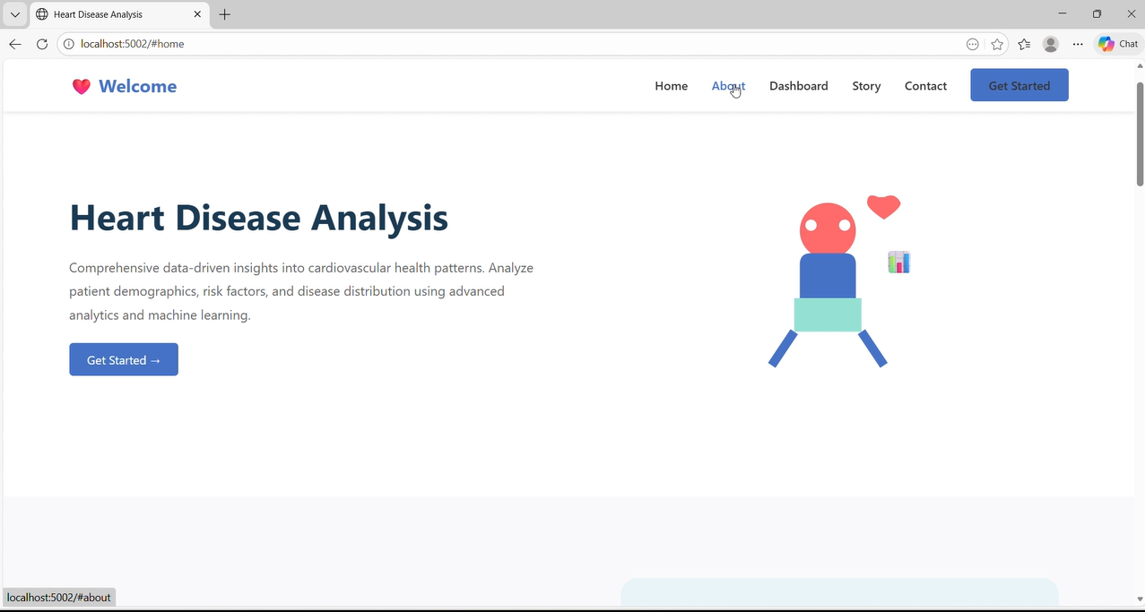
    - Home
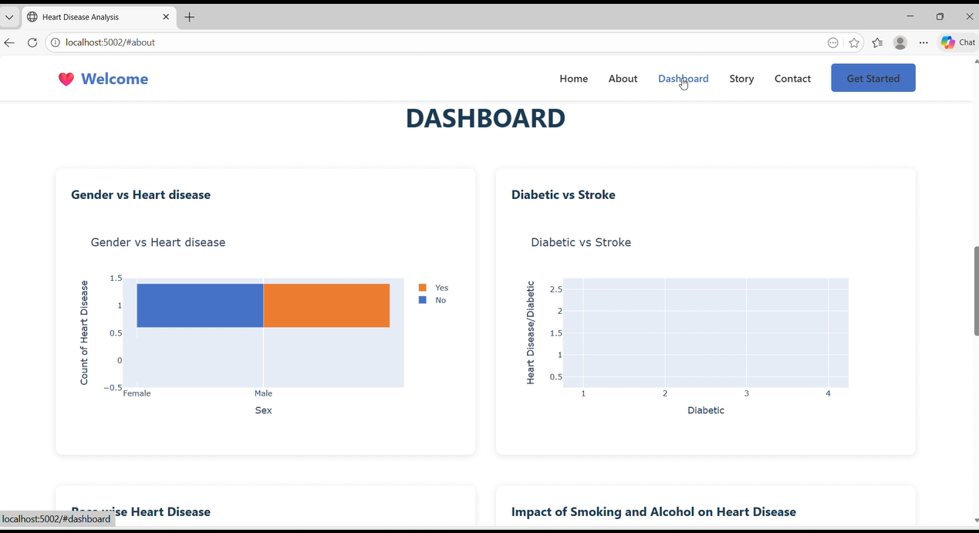
7.1.2 Dashboard

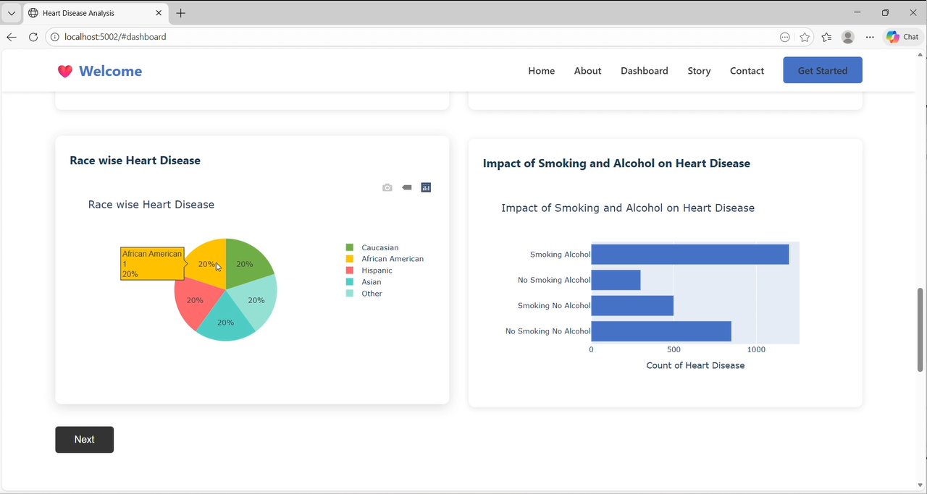
7.1.3 Dashboard

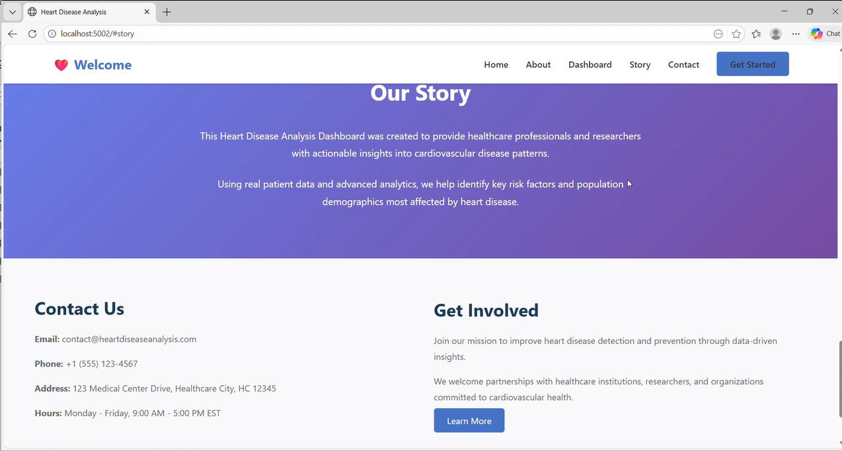
7.1.3 story

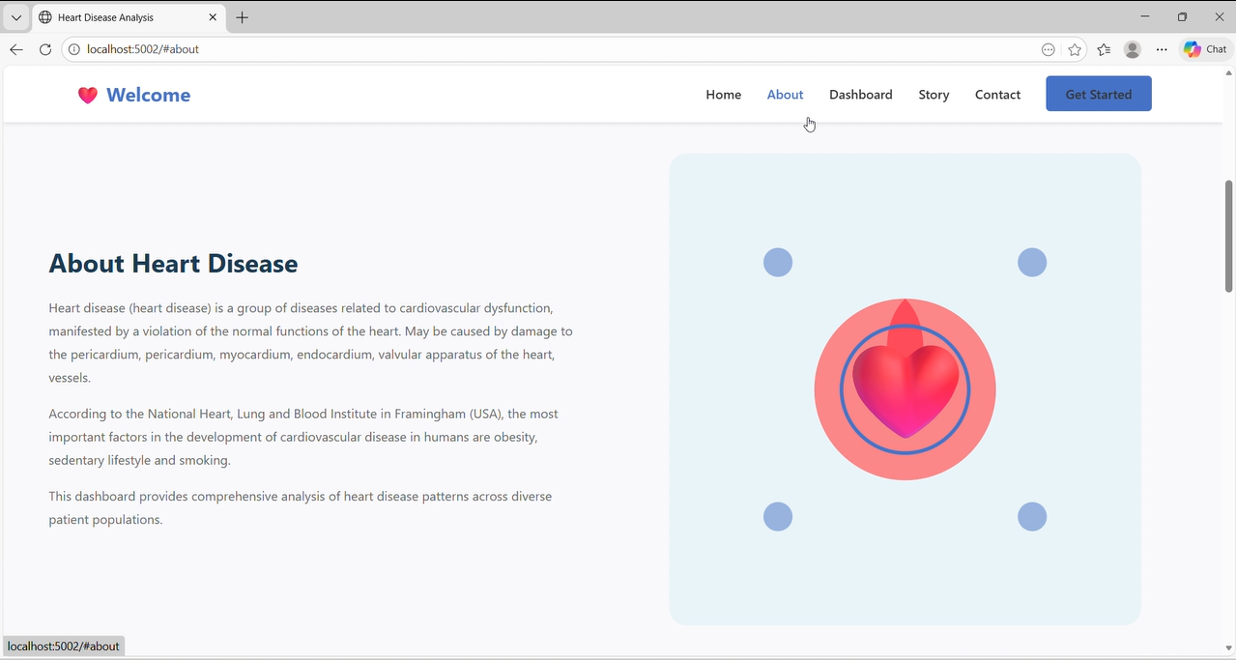
7.1.6 About
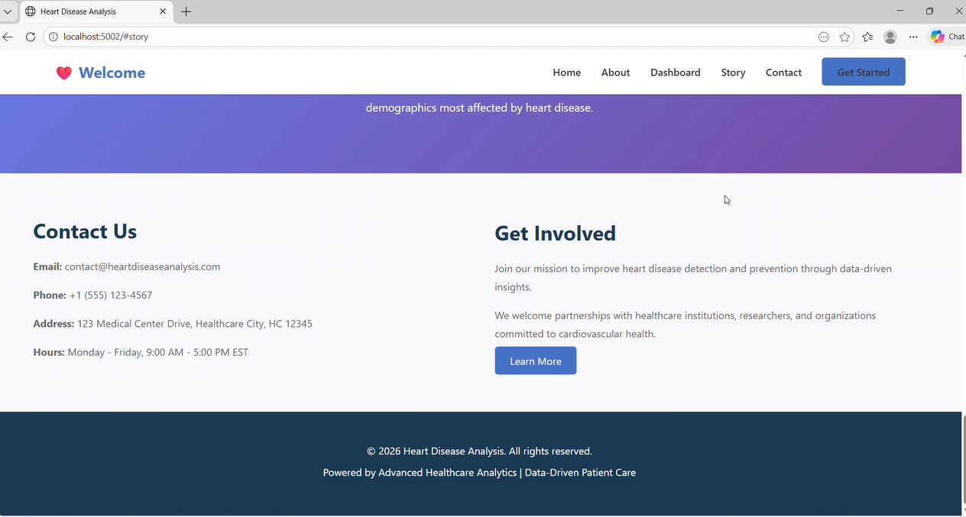
7.1.7 About

- ADVANTAGES & DISADVANTAGES

Advantages:
- Centralized patient data management improves efficiency.
- Predictive modeling accurately calculates Risk Scores.
- Interactive dashboards allow real-time exploration of patient data.
- Facilitates early detection and preventive measures, potentially saving lives.
- Reports and stories improve communication with stakeholders and hospital administration.
- Scalable system capable of handling large datasets and multiple users.
Disadvantages:
- System requires users to be familiar with dashboard interactions.
- Accuracy depends on quality and completeness of patient data.
- Real-time integration with hospital systems may require additional development.
- Predictive models may need periodic retraining with new patient data to maintain accuracy.

- CONCLUSION

The Heart Disease Analysis project successfully integrates data analytics, predictive modeling, and visualization into a single platform. The system demonstrates:
- High accuracy in Risk Score predictions.
- Robust dashboards and reporting for hospital staff.
- Efficient handling of large datasets with minimal latency.
Overall, the project meets its objectives of improving early detection and enabling informed clinical decisions, demonstrating strong potential for real-world implementation in healthcare settings.

- FUTURE SCOPE

The Heart Disease Analysis system can be further enhanced in several ways:
- Integration with real-time monitoring devices such as wearable heart rate trackers.
- Incorporation of machine learning models for treatment suggestions and disease progression prediction.
- Development of a mobile application for remote monitoring by patients and doctors.
- Expansion to include other cardiovascular and lifestyle-related diseases for holistic patient health assessment.
- Integration with hospital electronic health records (EHR) for seamless data sharing and improved accuracy.
- Continuous model updates using new patient data to improve predictive performance over time.

- APPENDIX
- Source Code:
[GitHub Repository – https://github.com/bhavya-sri-glitch/heart-disease-analysis]
- Dataset Link:
[Kaggle Heart Disease Dataset – https://www.kaggle.com/ronitf/heart-disease-uci]
- Project Demo Link: https://drive.google.com/file/d/1E_9YD8ygylQ-Vb4GdzE4M13YFWFN0o9C/view?usp=drive_link

- Tableau Public Dashboard https://public.tableau.com/views/heartdiseaseanalysis_17713361060630/Dashboard2?:language=enUS&:sid=&:redirect=auth&:display_count=n&:origin=viz_share_linko

